Hibernate

Scenario

Ozvitha Fernz Supermarket is maintaining their customer order details online as follows.

1. One customer can order many orders
2. One order can contains more than 1 items
3. One Item can be part of many orders
4. Only registered customers can order Items
5. If one order is taken from a customer, same order should not use for other customer
6. Billing should be calculated for a customer order wise.
7. Customers can view their billing details for single order, or for all orders made by particular customer

Now create Hibernate mapping classes for the following database for Ozvitha Fernz Supermarket

**Customer table**

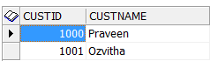

**Items Table**

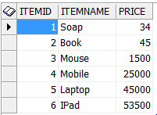

**Orders Table**

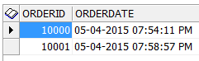

**Order_Details table**

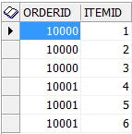

**Customer_Orders table**

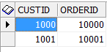

**Customer_Billing**



**ER – Diagram as follows**

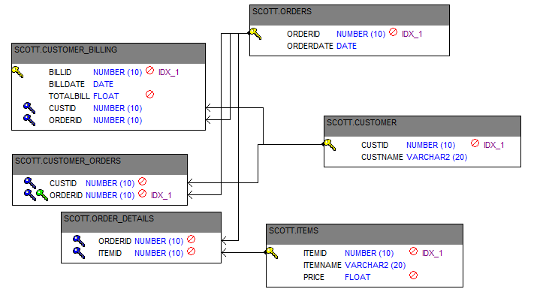

**Now create Hibernate class for printing following report from above mentioned tables**

Cust ID: 1000

Cust Name: Praveen

Order id :10000

Order Date: 2015-04-05 19:54:11.0

--------------------------------------

ItemId ItemName Price

--------------------------------------

1 Soap 34.0

2 Book 45.0

3 Mouse 1500.0

--------------------------------------

Bill Id: 500

Cust Id: 1000

Order Id: 10000

Bill Date: 2015-04-05 20:37:41.0

Total Bill Amount: 1579.0

--------------------------------------